

API Guide

Product Ordering

February 2018

Disclaimer

“This guide describes a set of APIs that may be implemented on one or more Interface Reference Points (IRPs) of the LSO Reference Architecture, as defined in MEF 55. This guide is not a MEF specification, and is not based on a MEF consensus-driven technical specification development process.

The information in this publication is freely available for reproduction and use by any recipient and is believed to be accurate as of its publication date. Such information is subject to change without notice and MEF Forum (MEF) is not responsible for any errors. MEF does not assume responsibility to update or correct any information in this publication. No representation or warranty, expressed or implied, is made by MEF concerning the completeness, accuracy, or applicability of any information contained herein and no liability of any kind shall be assumed by MEF as a result of reliance upon such information.

The information contained herein is intended to be used without modification by the recipient or user of this document. MEF is not responsible or liable for any modifications to this document made by any other party.

The receipt or any use of this document or its contents does not in any way create, by implication or otherwise:

(a) any express or implied license or right to or under any patent, copyright, trademark or trade secret rights held or claimed by any MEF member which are or may be associated with the ideas, techniques, concepts or expressions contained herein; nor

(b) any warranty or representation that any MEF member will announce any product(s) and/or service(s) related thereto, or if such announcements are made, that such announced product(s) and/or service(s) embody any or all of the ideas, technologies, or concepts contained herein; nor

(c) any form of relationship between any MEF member and the recipient or user of this document.

Implementation or use of specific MEF standards or recommendations and MEF specifications will be voluntary, and no Member shall be obliged to implement them by virtue of participation in MEF Forum. MEF is a non-profit international organization to enable the development and worldwide adoption of agile, assured and orchestrated network services. MEF does not, expressly or otherwise, endorse or promote any specific products or services.

© MEF Forum 2018. All Rights Reserved

Table of Contents

1. List of Contributing Members 1

2. Abstract 1

3. Scope 1

4. Product Ordering Resource Model 2

5. State Diagrams 3

6. Notifications 6

6.1 Subscribe to notification: 6

6.2 Receive Notification: 7

7. Data mapping with IPS 8

8. JSON representation sample 12

9. API Operations 18

9.1 Create Order 20

9.2 Retrieve Orders 26

9.3 Retrieve a single product order by order identifier 27

9.4 Change Order 28

9.5 Amend Order 29

9.6 Cancel Order 30

9.7 Disconnect Order 31

10. Appendix – Place description pattern 34

11. Appendix – Product Specification Description 35

11.1 Product Specification management in the API 35

List of Figures

Figure 1 Product Ordering Resource Model 2

Figure 2 Product Inventory State Machine 3

Figure 3 Product Order Item State Machine 4

Figure 4 Product Order API generic interaction 18

List of Tables

Table 1 Contributing Member Companies 1

Table 2 Order State Definition 4

Table 3 Compliance between Order State & Order Item State 5

Table 4 Mapping attribute IPS to API 12

Table 5 mapping UC – API operation 17

# List of Contributing Members

The following members of MEF participated in the development of this document and have requested to be included in this list.

|  |  |
| --- | --- |
| AT&T | Orange |
| Cataworks | Telus |
| Colt |  |
|  |  |

*Table 1 Contributing Member Companies*

# Abstract

This API Guide is intended to help company to implement MEF Product Ordering Management API. The API swagger is available on MEF GitHub. In order to help API adoption this document provides:

* API Resource Model
* Resource ProductOrder lifecycle (as well as subResource OrderItem lifecycle)
* Resource ProductOrder full representation
* Detailed description of all API Operations provided

# Scope

The scope of this API guide covers project the following capabilities for productOrdering:

* Create Order to request install new product
* Change order: create Order to change an existing Product
* Disconnect Order: create Order to disconnect an existing Product
* Cancel Order: cancellation of an inflight-order
* Amend Order: modification of an inflight-order
* Retrieve Order(s) based on criteria
* Get full data of an order based on its id.
* Support for Order Notifications

# Product Ordering Resource Model

The API Product Ordering resource model is the following:

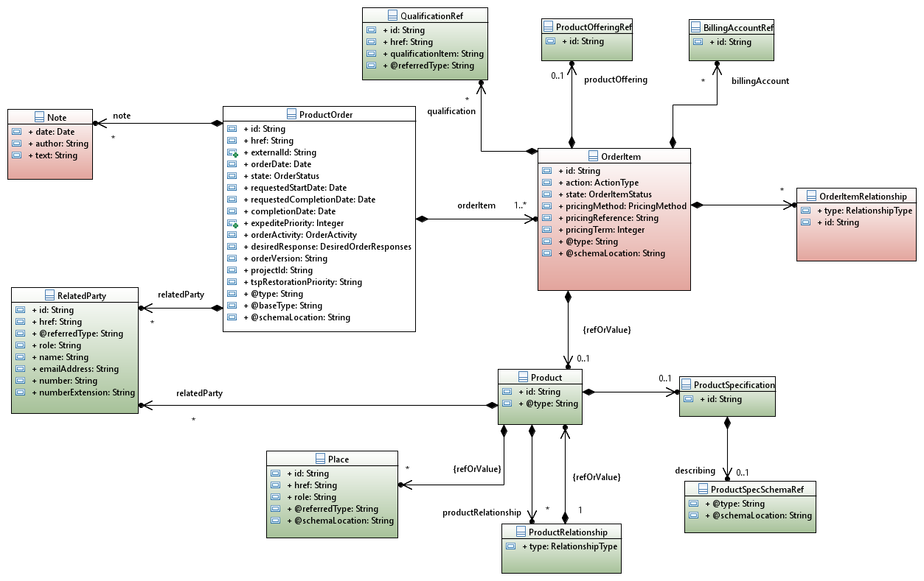

Figure 1 Product Ordering Resource Model

Color coding scheme:

* White box: API main resource
* Pink box: API sub resource(s)
* Green Boxes : API related/referred resource(s)

# State Diagrams

Following diagram shows the state machine for a Product Order:

Figure 2 Product Inventory State Machine

Following table provided state definition:

|  |  |
| --- | --- |
| Product Order State | Definition |
| REJECTED | One of the following has occurred:  1. The order has failed feasibility check  2. Invalid information was provided on the order  3. The order fails to meet business rules for ordering |
| ACKNOWLEDGED | An order has been received and has passed message and basic business validations |
| IN_PROGRESS | An order has passed the order feasibility check successfully and service delivery has started |
| PENDING | The order is currently in a waiting stage for an action/activity to be completed before the order can progress further, pending order amend or cancel assessment |
| HELD | An order cannot be progressed due to an issue that is blocking on the side of the seller. |
| ASSESSING_CANCELLATION | A request has been made by the buyer or seller to cancel the order and the order is currently being assessed to determine whether it can be cancelled or not. |
| PENDING_CANCELLATION | Seller approved the cancellation request and this cancellation is in progress |
| CANCELLED | The in-flight order has been successfully cancelled |
| CONFIGURED | Prior to confirmation of the order, the seller configures seller specific data such as Seller UNI ID, Seller ENNI ID, Seller OVC ID, etc. |
| CONFIRMED | The order is committed to delivery on an expected delivery date. |
| JEOPARDY | The order is in danger of not meeting its expected delivery date. The seller may request that a new, corrected order be submitted. |
| PARTIAL | Some order items have failed and some have completed |
| FAILED | All order items have failed which results in the order failing |
| COMPLETED | An order has completed provisioning and the service is now active |

Table 2 Order State Definition

Following diagram shows the state machine for a Product Order Item:

Figure 3 Product Order Item State Machine

Because order item states are a subset of the one provided for order please look definition on above table.

Compliance table between order state and order item state:

|  |  |
| --- | --- |
| Product Order State | Condition |
| REJECTED | At least order item with Rejected state |
| ACKNOWLEDGED | All order item are in Acknowledged state(fulfillment has not yet started) |
| IN_PROGRESS | At least fulfillment started for one item – one item must have Pending, Held, Assessing Cancellation, Configured, Completed or Failed Status.  If all item AND not any below condition are applicable |
| PENDING | All order items are Pending or Cancelled; At least one Pending |
| HELD | All order items are Held or Cancelled; At least one Held |
| ASSESSING_CANCELLATION | All order items are AssessingCancellation or Cancelled; At least one Pending |
| CANCELLED | All order items are Cancelled |
| CONFIGURED | All order items are Configured or Cancelled; At least one Configured |
| CONFIRMED | All order items are Configured or Cancelled; At least one Configured |
| JEOPARDY | All order items are Configured or Cancelled; At least one Configured |
| PARTIAL | All order items are Completed, Failed or Cancelled; At least one Completed and one Failed |
| FAILED | All order items are Failed or Cancelled; At least one Failed |
| COMPLETED | All order items are Completed or Cancelled; At least one Completed |

*Table 3 Compliance between Order State & Order Item State*

# Notifications

Following notifications are managed in this API:

* ProductOrderAttributeValueChangeNotification
* ProductOrderStateChangeNotification

In order to receive Notification, buyer needs

* to subscribe to a notification
* to provide an Event API in order to allow seller to POST him notifications.

## Subscribe to notification:

By doing the following request SP1 will subscribe to productOrder state change for his orders:

POST {api_url}/HUB

Accept: application/json

{"callback": <http://in.listener.com>,

“query”:”eventType = ProductOrderStateChangeNotification”

}

In yellow, this is the address where Buyer wants to receive the order state change notifications.

The response will be:

201

Content

-

Type:

application/json

Location: /api/hub/42

{"id":"42","callback":"<http://in.listener.com>","query":”eventType = ProductOrderStateChangeNotification”}

Note: 42 is the id of an HUB resource not a productOrder id

Seller provides GET and DELETE operations on HUB resource in order to allow buyer to retrieve his hub and delete them if necessary:

GET {api_url}/HUB

Accept: application/json

You will have list of your HUB on this API

[

  {

    "id": "42",

    "query": " eventType = ProductOrderStateChangeNotification ",

    "callback": " <http://in.listener.com> "

  },

  {

    "id": "98",

    "query": " eventType = • ProductOrderAttributeValueChangeNotification",

    "callback": " <http://in.listener.com> "

  }

]

Buyer did not want any more notification for productOrder attribute value change:

DELETE {api_url}/HUB/98

Accept: application/json

## Receive Notification:

Now that buyer has subscribed to notification for productOrder status change for example, let’s suppose that he posted a productOrder and this one is processed by the seller. The productOrder state changes. Seller will POST an Event to the Buyer:

POST {callback}/event

{

"eventType": " ProductOrderStateChangeNotification",

"eventTime": "2014-09-27T05:46:25.0Z",

"eventId": "92445",

"event":

{

"productOrder": {

“id”: “456987”

}

}

Buyer will response with a standard HTTP 201 if event received.

# Data mapping with IPS

The following table provides a mapping between IPS attributes and API attributes

| IPS Class Model | Ethernet Ordering Technical Specification | API resource or sub-resource | API attribute |
| --- | --- | --- | --- |
| *productOrder* |  |  |  |
| expeditePriority | Expedite Priority | ProductOrder | expeditePriority |
| buyerOrderVersion | Buyer Order Version | ProductOrder | version |
| buyerPONumber | Buyer Purchase Order Number | ProductOrder | externalId |
| orderDate | Order Date | ProductOrder | orderDate |
| orderActivity | Order Activity | ProductOrder | orderActivity |
| state | Order Status (not on create) | ProductOrder | state |
| requestedCompletionDate | Requested Completion Date | ProductOrder | requestedCompletionDate |
| completionDate | Completion Date (not on create) | ProductOrder | completionDate |
| projectId | Project ID | ProductOrder | projectId |
| note | Note | Note | Note |
| desiredResponses | Desired Responses | ProductOrder | desiredResponse |
| id | Order ID | ProductOrder | id |
| requestedStartDate | Requested Start Date |  | requestedStartDate |
| tspRestorationPriority | Telecommunication Service Priority/Restoration Priority | ProductOrder | tspRestorationPriority |
| _orderItem |  | ProductOrder | OrderItem |
| _relatedParty |  | ProductOrder | RelatedParty |
| *Order Item* |  |  |  |
| state |  | OrderItem | state |
| id | Order Item Reference Number | OrderItem | id |
| action | Order Item Action | OrderItem | action |
| pricingMethod | Pricing Method | OrderItem | pricingMethod |
| pricingReference | Pricing Reference | OrderItem | pricingReference |
| pricingTerm | Pricing Term | OrderItem | pricingTerm |
| _productOffering | Promotion ID | ProductOfferingRef | id |
| _product |  | OrderItem | Product |
| _billingAccount | Billing Account | OrderItem | BillingAccountRef |
| _orderItemRelationship |  | OrderItem | OrderItemRelationship |
| qualificationId | Serviceability Response Identifier | QualificationRef | Id |
| *Order Item Relationship* |  |  |  |
| type |  | OrderItem.orderItemRelationship | type |
| id |  | OrderItem.orderItemRelationship | id |
| *Billing Account* |  |  |  |
| accountNumber | Billing Account | BillingAccountRef | id |
| *Related Party* |  |  |  |
| id | Buyer Id, Seller Id | RelatedParty | id |
| role | "Buyer", "Seller", "Billing Contact", "Order Contact", "Implementation Contact", "Technical Contact", "UNI Site Contact", "UNI Alt Site Contact", "ENNI Site Contact", "ENNI Alt Site Contact" | RelatedParty | role |
| emailAddress | Billing Contact Email Address | RelatedParty | emailAddress where RelatedParty.role="Billing Contact" |
| number | Billing Contact Telephone Number | RelatedParty | number where RelatedParty.role="Billing Contact" |
| numberExtension | Billing Contact Telephone Extension | RelatedParty | numberExtension where RelatedParty.role="Billing Contact" |
| name | Billing Contact Contact Name | RelatedParty | name where RelatedParty.role="Billing Contact" |
|  | Buyer Order Contact Email Address | RelatedParty | emailAddress where RelatedParty.role="Order Contact" |
|  | Buyer Order Contact Telephone Number | RelatedParty | number where RelatedParty.role="Order Contact" |
|  | Buyer Order Contact Number Extension | RelatedParty | numbeExtension where RelatedParty.role="Order Contact" |
|  | Buyer Order Contact Name | RelatedParty | name where RelatedParty.role="Order Contact" |
|  | Buyer Implementation Contact Email Address | RelatedParty | emailAddress where RelatedParty.role="Implementation Contact" |
|  | Buyer Implementation Contact Telephone Number | RelatedParty | number where RelatedParty.role="Implementation Contact" |
|  | Implementation Contact Telephone Number Extension | RelatedParty | numbeExtension where RelatedParty.role="Implementation Contact" |
|  | Buyer Implementation Contact Name | RelatedParty | name where RelatedParty.role="Implementation Contact" |
|  | Buyer Technical Contact Email Address | RelatedParty | emailAddress where RelatedParty.role="Technical Contact" |
|  | Buyer Technical Contact Telephone Number | RelatedParty | number where RelatedParty.role="Technical Contact" |
|  | Buyer Technical Contact Telephone Number Extension | RelatedParty | numbeExtension where RelatedParty.role="Technical Contact" |
|  | Buyer Technical Contact Name | RelatedParty | name where RelatedParty.role="Technical Contact" |
|  | ENNI Site Contact Email Address | RelatedParty | emailAddress where RelatedParty.role="ENNI Site Contact" |
|  | ENNI Site Contact Telephone Number | RelatedParty | number where RelatedParty.role="ENNI Site Contact" |
|  | ENNI Site Contact Telephone Number Extension | RelatedParty | numbeExtension where RelatedParty.role="ENNI Site Contact" |
|  | ENNI Site Contact Name | RelatedParty | name where RelatedParty.role="ENNI Site Contact" |
|  | ENNI Alt. Site Contact Email Address | RelatedParty | emailAddress where RelatedParty.role="ENNI Alt. Site Contact" |
|  | ENNI Alt. Site Contact Telephone Number | RelatedParty | number where RelatedParty.role="ENNI Alt. Site Contact" |
|  | ENNI Alt. Site Contact Telephone Number Extension | RelatedParty | numbeExtension where RelatedParty.role="ENNI Alt. Site Contact" |
|  | ENNI Alt. Site Contact Name | RelatedParty | name where RelatedParty.role="ENNI Alt. Site Contact" |
| *Place* |  |  |  |
| id | Not in Ordering TS | Place | id |
| role | Not in Ordering TS | Place | role |
| type | SiteAddressType | Place | @type |
| *Service Site* |  |  |  |
| siteCompanyName | UNI Site Company Name | This information could be capturer to create a site when fieldedAddress, FormattedAddress, GeographicLocation or ReferencedAddress are described | siteCompanyName |
| endCustomerName | UNI Site Customer Name | same | endCustomerName |
| additionalSiteInformation | UNI Site Additional Site Information | same | additionalSiteInformation |
| siteDescription |  | same | siteDescription |
| *Fielded Address* |  |  |  |
| streetNr | Street Number | for @type=”FieldedAddress” | streetNr |
| streetNrSuffix | Street Number Suffix | for @type=”FieldedAddress” | streetNrSuffix |
| streetNrLast | Street Number Last | for @type=”FieldedAddress” | streetNrLast |
| streetNrLastSuffix |  | for @type=”FieldedAddress” | streetNrLastSuffix |
| streetName | Street Name | for @type=”FieldedAddress” | streetName |
| streetType | Street Type | for @type=”FieldedAddress” | streetType |
| streetSuffix | Street Suffix | for @type=”FieldedAddress” | streetSuffix |
| city | City | for @type=”FieldedAddress” | city |
| locality | Locality | for @type=”FieldedAddress” | locality |
| postcode | Postal Code | for @type=”FieldedAddress” | postcode |
| postcodeExtension | Postal Code Extension | for @type=”FieldedAddress” | postcodeExtension |
| country | Country | for @type=”FieldedAddress” | country |
| stateOrProvince | State or Province | for @type=”FieldedAddress” | stateOrProvince |
| *Fielded SubAddress* |  |  |  |
| buildingName | Building Name | for @type=”FieldedAddress” then subAdress | buildingName |
| levelNr | Level Number | for @type=”FieldedAddress” then subAdress | levelNr |
| levelType | Level Type | for @type=”FieldedAddress” then subAdress | levelType |
| privateStreetName | Private Street Name | for @type=”FieldedAddress” then subAdress | privateStreetName |
| subUnitNr | Sub Unit Number | for @type=”FieldedAddress” then subAdress | subUnitNr |
| subUnitType | Sub Unit Type | for @type=”FieldedAddress” then subAdress | subUnitType |
| *Referenced Address* |  |  |  |
| referenceType | Only exists in serviceability TS | for @type=”ReferencedAddress” | referenceType |
| referenceId | Address Reference Id | for @type=”ReferencedAddress” | referenceId |
| *Formatted Address* |  |  |  |
| addrLine1 | Formatted Address Line 1 | for @type=”FormattedAddress” | addrLine1 |
| addrLine2 | Formatted Address Line 2 | for @type=”FormattedAddress” | addrLine2 |
| locality | Locality | for @type=”FormattedAddress” | locality |
| city | City | for @type=”FormattedAddress” | city |
| stateOrProvince | StateOrProvince | for @type=”FormattedAddress” | stateOrProvince |
| postcode | Postcode | for @type=”FormattedAddress” | postcode |
| postcodeExtension | PostcodeExtension | for @type=”FormattedAddress” | postcodeExtension |
| country | County | for @type=”FormattedAddress” | country |
| *Geographic Point* |  | In the API we'll use GeoLocation structure with Type="point". z coordinate (elevation) will not be used | |
| spatial | Not in TS | for @type=”GeograpicLocation” | spatial |
| latitude | In single field "latitude/longitude" | for @type=”GeograpicLocation” | latitude |
| longitude | In single field "latitude/longitude" | for @type=”GeograpicLocation” | longitude |
| *Product* |  |  |  |
| id |  | product | id |
| _relatedParty |  | product | relatedParty |
| _productRelationship | Not specified in TS | productRelationship |  |
| _place | Pointer to the place for a UNI/ENNI product. | GeoLocation or Address or Site | id (use place role to refer the 'right' place) |
| _productSpec | Product Specification | ProductSpecificationRef | id |
| *Product Relationship* |  |  |  |
| type | Not specified in TS | productRelationship | type |
| _product | Not specified in TS | productRelationship | targeted product.id |
| *Product Offering* |  |  |  |
| id | Not specified in TS | ProductOfferingRef | id |

*Table 4 Mapping attribute IPS to API*

# JSON representation sample

We provide below the JSON representation of an example of a 'Product' resource object

**Important note about product description:** The productOrder API is **product-agnostic**. The product specification information is managed with an API extension pattern and it must be dynamically added in API instantiated message. All productSpec attributes are not directly described in this API and in the swagger.

This loose decoupling between the API itself and the ProductSpec allow us to provide a lot of flexibility. Introduction of new product or release of new version for existing product will not trigger impact on the API itself and will not require a new API release.

To allow reader to identify where ordered product characteristics must be added on API instantiation, depending on ordered product, we added the comment *<< This is where productspec characteristics would be given value>>* where these attributes should be present.

This example illustrates an order for new UNI+eLine+both endpoints:

|  |
| --- |
| {  "id":"456987",  "href":"https://spDB//productOrdering/productOrder/456789",  "externalId":"AZCO456",  "orderDate":"2018-02-15T14:05:03.498Z",  "state":"IN_PROGRESS",  "requestedStartDate":"2018-02-16T14:05:03.498Z",  "requestedCompletionDate":"2018-02-17T14:05:03.498Z",  "completionDate":"",  "expeditePriority":0,  "orderActivity":"INSTALL",  "desiredResponses":"CONFIRMATION_AND_ENGINEERING_DESIGN",  "orderVersion":"1",  "projectId":"AZCO",  "tspRestorationPriority":"2",  "relatedParty":[  {  "role":"buyer",  "name":"Siva",  "emailAddress":"siva@mef.net",  "number":"4698521478",  "numberExtension":"12"  },  {  "role":"Seller",  "name":"Ludovic",  "emailAddress":"ludo@mef.net",  "number":"0698524595"  }  ],  "note":{  "text":"ProductOrder following discussion established Jan 14, 2018",  "date":"2018-02-15T14:05:03.498Z",  "author":"Siva"  },  "orderItem":[  {  "id":"1",  "action":"INSTALL",  "state":"IN_PROGRESS",  "billingAccount":{  "id":"BA123654"  },  "productOffering":{  "id":"OrangeUNI"  },  "product":{  "productSpecification":{  "id":"UNISpec",  "describing":{  "@type":"UNISpec",  "@schemaLocation":"https://github.com/MEF-GIT/MEF-LSO-Sonata-SDK/blob/master/experimental/api/ProductSpecDescription/Ordering/UNISpec.json"  }  },  *<< This is where productspec characteristics would be given value>>*  *},*  "place":[  {  "role":"UNI Site",  "@referredType":"FormattedAddress",  "@schemaLocation":"https://github.com/MEF-GIT/MEF-LSO-Sonata-SDK/blob/master/experimental/api/PlaceDescription/FormattedAddress.json",  "addrline1":"12 Avenue Pierre Marie",  "city":"Lyon",  "stateorProvince":"Rhone",  "postcode":"69001",  "country":"France"  }  ],  "relatedParty":[  {  "role":"Technical Contact",  "name":"Jessie",  "emailAddress":"jessie@mef.net",  "number":"0625413698"  },  {  "role":"Implementation Contact",  "name":"Jessie",  "emailAddress":"jessie@mef.net",  "number":"0625413698"  },  {  "role":"UNI Site Contact",  "name":"Jessie",  "emailAddress":"jessie@mef.net",  "number":"0625413698"  }  ]  },  "qualification":[  {  "id":"1369-4523",  "href":"https://spDB/productOfferingqualificationManagement/POQ/1369-4523",  "qualificationItem":"1"  }  ]  },  {  "id":"2",  "action":"INSTALL",  "state":"ACKNOWLEDGED",  "productOffering":{  "id":"OrangeELine"  },  "product":{  "productSpecification":{  "id":"eLineSpec",  "describing":{  "@type":"eLineSpec",  "@schemaLocation":"https://github.com/MEF-GIT/MEF-LSO-Sonata-SDK/blob/master/experimental/api/ProductSpecDescription/Ordering/ELineSpec.json"  }  },  *<< This is where productspec characteristics would be given value>>*  "place":[  {  "id":"AZe78-45fgh6-45de5r",  "role":"ENNI Site",  "@referredType":"site"  }  ],  "relatedParty":[  {  "role":"Technical Contact",  "name":"Hunter Pence",  "emailAddress":"hunter@giants.com",  "number":"4156987852369"  },  {  "role":"ENNI Site Contact",  "name":"Andrew Mc Clutchen",  "emailAddress":"andrew@giants.com",  "number":"4152236698741"  }  ]  },  "qualification":[  {  "id":"1369-4523",  "href":"https://spDB/productOfferingqualificationManagement/POQ/1369-4523",  "qualificationItem":"2",  "@referredType":"string"  }  ]  },  {  "id":"3",  "action":"INSTALL",  "state":"ACKNOWLEDGED",  "productOffering":{  "id":"UNICEEndPoint"  },  "product":{  "productSpecification":{  "id":"UNICEEndPointspec",  "describing":{  "@type":"UNICEEndPointspec",  "@schemaLocation":"https://github.com/MEF-GIT/MEF-LSO-Sonata-SDK/blob/master/experimental/api/ProductSpecDescription/Ordering/UNICEEndPointSpec.json"  }  },  *<< This is where productspec characteristics would be given value>>*  *},*  "orderItemRelationship":[  {  "type":"RELIES_ON",  "id":"1"  },  {  "type":"RELIES_ON",  "id":"2"  }  ],  "qualification":[  {  "id":"1369-4523",  "href":"https://spDB/productOfferingqualificationManagement/POQ/1369-4523",  "qualificationItem":"3",  "@referredType":"string"  }  ]  },  {  "id":"4",  "action":"INSTALL",  "state":"ACKNOWLEDGED",  "productOffering":{  "id":"ENNICEEndPoint"  },  "product":{  "productSpecification":{  "id":"ENNICEEndPointSpec",  "describing":{  "@type":"ENNICEEndPointSpec",  "@schemaLocation":"https://github.com/MEF-GIT/MEF-LSO-Sonata-SDK/blob/master/experimental/api/ProductSpecDescription/Ordering/ENNICEEndPointSpec.json"  }  },  *<< This is where productspec characteristics would be given value>>*  "productRelationship":[  {  "type":"RELIES_ON",  "product":{  "id":"45df-er26-456r-85gh"  }  }  ]  },  "orderItemRelationship":[  {  "type":"RELIES_ON",  "id":"2"  }  ],  "qualification":[  {  "id":"1369-4523",  "href":"https://spDB/productOfferingqualificationManagement/POQ/1369-4523",  "qualificationItem":"3"  }  ],  "@type":"string",  "@schemaLocation":"string"  }  ],  "@type":"MEFProductOrder",  "@schemaLocation":"https://..."  } |

# API Operations

In the following table, the use cases and operations defined in the IPS are mapped to the API use cases:

|  |  |  |  |
| --- | --- | --- | --- |
| Use Case | Operation | Uniform API Operation | Description |
| UC_SONATA_ORDER_0001 | Create Order | POST | All order item action set to ‘INSTALL” |
| UC_SONATA_ORDER_0002 | Retrieve Orders | GET | without an id but with criteria |
| UC_SONATA_ORDER_0003 | Retrieve a single product order by order identifier | GET | with an id |
| UC_SONATA_ORDER_0004 | Change Order | POST | All order item action set to ‘CHANGE” or “INSTALL” or “DISCONNECT” (no all with “INSTALL” or with “DISCONNECT”) |
| UC_SONATA_ORDER_0005 | Amend Order | PATCH |  |
| UC_SONATA_ORDER_0006 | Cancel Order | Specific operation  POST /productOrder/{productOrderId}/cancel | This operation allow to not cancel an order but to post a request to an order cancellation |
| UC_SONATA_ORDER_0007 | Disconnect Order | POST | All order item action set to “DISCONNECT” |
| UC_SONATA_ORDER_0008 | Attribute Value Change (AVC) Notification | No operation | Notification send during order procession – need buyer to have subscribed beforehand |
| UC_SONATA_ORDER_0009 | Status Change Notification | Notification | Notification send during order procession – need buyer to have subscribed beforehand |

Table 5 mapping UC – API operation

The product order interaction model is described below:

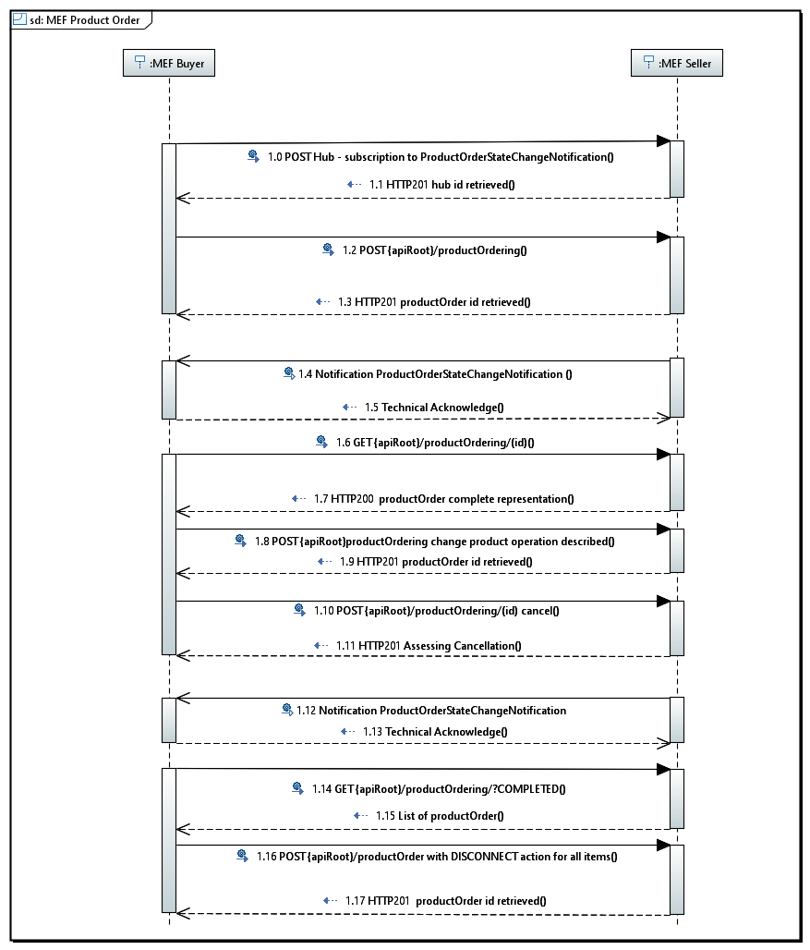

Figure 4 Product Order API generic interaction

## Create Order

POST {apiRoot}/productOrder

Description

This operation creates a product order entity

Behavior

Standard 201 response if product order created

Otherwise:

|  |  |
| --- | --- |
| 400 | Bad Request |
| 401 | Unauthorized |
| 403 | Forbidden |
| 405 | Method Not Allowed |
| 408 | Request Time-out |
| 422 | Unprocessable entity (see below) |

Specific business errors will be encapsulated in HTTP Response 422 Unprocessable entity:

* 100: Missing order item (minimum 1) At least one order item must be provided
* 101: Missing Buyer at order level one and only one related party with a "Buyer" role should be provided at the product order level.
* 102: A relatedParty is at the wrong level The party role provided is not managed - MEF allows to have "Buyer", "Seller", "Billing Contact", "Order Contact", "Implementation Contact", "Technical Contact" roles at product order level "UNI Site Contact", "UNI Alt Site Contact", "ENNI Site Contact", "ENNI Alt Site Contact" at product order item level.
* 103: Missing Buyer Contact at order level one and only one related party with an "Order Contact" role should be provided at the product order level. Buyer Contact name & Telephone number must be provided.
* 104: Missing Buyer Implementation Contact at order level one and only one related party with a "Implementation Contact" role should be provided at the product order level. Implementation Contact name & Telephone number must be provided.
* 105: Missing Buyer Technical contact at order level one and only one related party with a "Technical Contact" role should be provided at the product order level. Technical Contact name, Telephone number and email address must be provided.
* 108: If orderItemAction is not INSTALL, orderItem.product.id is mandatory
* 109: If orderActivity is set to INSTALL, all orderItemAction must be INSTALL
* 110: Quote expired – (use to be defined later)
* 111: If orderActivity is set to DISCONNECT, all orderItemAction must be DISCONNECT
* 112: if orderActivity is set to CHANGE, all order item must not be all DISCONNECT or INSTALL

Usage Samples

Request:

|  |
| --- |
| POST {api_url}/productOrderingManagement/productOrder  Content-Type: application/json  {  "externalId":"AZCO456",  "requestedStartDate":"2018-02-16T14:05:03.498Z",  "requestedCompletionDate":"2018-02-17T14:05:03.498Z",  "expeditePriority":0,  "orderActivity":"INSTALL",  "desiredResponses":"CONFIRMATION_AND_ENGINEERING_DESIGN",  "orderVersion":"1",  "projectId":"AZCO",  "tspRestorationPriority":"2",  "relatedParty":[  {  "role":"buyer",  "name":"Siva",  "emailAddress":"siva@mef.net",  "number":"4698521478",  "numberExtension":"12"  },  {  "role":"Seller",  "name":"Ludovic",  "emailAddress":"ludo@mef.net",  "number":"0698524595"  }  ],  "note":{  "text":"ProductOrder following discussion established Jan 14, 2018",  "date":"2018-02-15T14:05:03.498Z",  "author":"Siva"  },  "orderItem":[  {  "id":"1",  "action":"INSTALL",  "billingAccount":{  "id":"BA123654"  },  "productOffering":{  "id":"OrangeUNI"  },  "product":{  "productSpecification":{  "id":"UNISpec",  "describing":{  "@type":"UNISpec",  "@schemaLocation":"https://github.com/MEF-GIT/MEF-LSO-Sonata-SDK/blob/master/experimental/api/ProductSpecDescription/Ordering/UNISpec.json"  }  },  << This is where productspec characteristics would be given value>>  },  "place":[  {  "role":"UNI Site",  "@referredType":"FormattedAddress",  "@schemaLocation":"https://github.com/MEF-GIT/MEF-LSO-Sonata-SDK/blob/master/experimental/api/PlaceDescription/FormattedAddress.json",  "addrline1":"12 Avenue Pierre Marie",  "city":"Lyon",  "stateorProvince":"Rhone",  "postcode":"69001",  "country":"France"  }  ],  "relatedParty":[  {  "role":"Technical Contact",  "name":"Jessie",  "emailAddress":"jessie@mef.net",  "number":"0625413698"  },  {  "role":"Implementation Contact",  "name":"Jessie",  "emailAddress":"jessie@mef.net",  "number":"0625413698"  },  {  "role":"UNI Site Contact",  "name":"Jessie",  "emailAddress":"jessie@mef.net",  "number":"0625413698"  }  ]  },  "qualification":[  {  "id":"1369-4523",  "href":"https://spDB/productOfferingqualificationManagement/POQ/1369-4523",  "qualificationItem":"1"  }  ]  },  {  "id":"2",  "action":"INSTALL",  "productOffering":{  "id":"OrangeELine"  },  "product":{  "productSpecification":{  "id":"eLineSpec",  "describing":{  "@type":"eLineSpec",  "@schemaLocation":"https://github.com/MEF-GIT/MEF-LSO-Sonata-SDK/blob/master/experimental/api/ProductSpecDescription/Ordering/ELineSpec.json"  }  },  << This is where productspec characteristics would be given value>>  "place":[  {  "id":"AZe78-45fgh6-45de5r",  "role":"ENNI Site",  "@referredType":"site"  }  ],  "relatedParty":[  {  "role":"Technical Contact",  "name":"Hunter Pence",  "emailAddress":"hunter@giants.com",  "number":"4156987852369"  },  {  "role":"ENNI Site Contact",  "name":"Andrew Mc Clutchen",  "emailAddress":"andrew@giants.com",  "number":"4152236698741"  }  ]  },  "qualification":[  {  "id":"1369-4523",  "href":"https://spDB/productOfferingqualificationManagement/POQ/1369-4523",  "qualificationItem":"2",  "@referredType":"string"  }  ]  },  {  "id":"3",  "action":"INSTALL",  "productOffering":{  "id":"UNICEEndPoint"  },  "product":{  "productSpecification":{  "id":"UNICEEndPointspec",  "describing":{  "@type":"UNICEEndPointspec",  "@schemaLocation":"https://github.com/MEF-GIT/MEF-LSO-Sonata-SDK/blob/master/experimental/api/ProductSpecDescription/Ordering/UNICEEndPointSpec.json"  }  },  << This is where productspec characteristics would be given value>>  },  "orderItemRelationship":[  {  "type":"RELIES_ON",  "id":"1"  },  {  "type":"RELIES_ON",  "id":"2"  }  ],  "qualification":[  {  "id":"1369-4523",  "href":"https://spDB/productOfferingqualificationManagement/POQ/1369-4523",  "qualificationItem":"3",  "@referredType":"string"  }  ]  },  {  "id":"4",  "action":"INSTALL",  "productOffering":{  "id":"ENNICEEndPoint"  },  "product":{  "productSpecification":{  "id":"ENNICEEndPointSpec",  "describing":{  "@type":"ENNICEEndPointSpec",  "@schemaLocation":"https://github.com/MEF-GIT/MEF-LSO-Sonata-SDK/blob/master/experimental/api/ProductSpecDescription/Ordering/ENNICEEndPointSpec.json"  }  },  << This is where productspec characteristics would be given value>>  "productRelationship":[  {  "type":"RELIES_ON",  "product":{  "id":"45df-er26-456r-85gh"  }  }  ]  },  "orderItemRelationship":[  {  "type":"RELIES_ON",  "id":"2"  }  ],  "qualification":[  {  "id":"1369-4523",  "href":"https://spDB/productOfferingqualificationManagement/POQ/1369-4523",  "qualificationItem":"3"  }  ],  "@type":"string",  "@schemaLocation":"string"  }  ],  "@type":"MEFProductOrder",  "@schemaLocation":"https://..."  } |

|  |
| --- |
| 201  {  "id": "456987"  } |

## Retrieve Orders

GET {apiRoot}/productOrder?{filtering}

Description

This operation is used to retrieve product order(s) corresponding to search criteria(s)

The response will be a product order summary.

Only following attributes could be used as search criteria

* externalId
* orderDate
* state
* requestedCompletionDate
* projectId

Only following attributes will be retrieved in summary view:

* id
* externalId
* orderDate
* state
* requestedCompletionDate
* projectId

Behavior

* Returns HTTP/1.1 status code 200 if the request was successful

Note: if no productOrder match the criteria an empty list is retrieved with a 200 status code (not considered as a fail)

Otherwise:

|  |  |
| --- | --- |
| 400 | Bad Request |
| 401 | Unauthorized |
| 403 | Forbidden |
| 405 | Method Not Allowed |
| 408 | Request Time-out |
| 422 | Unprocessable entity (see below) |

Usage Samples

Request

|  |
| --- |
| GET {api_url}/productOrderingManagement/productOrder ?state=acknowledged&projectId=Air France Customer &orderDate>2017-01-01 Accept: application/json |

Response

|  |
| --- |
| [  {  "id": "17",  "externalId": " OrangeforAirFrance002",  "orderDate": "2017-06-16T07:54:51.696Z",  "state": "acknowledged",  "requestedCompletionDate": "2017-06-16T07:54:51.696Z",  "projectId": "Air France Customer "  },  {  "id": "45",  "externalId": " OrangeforAirFrance003",  "orderDate": "2017-06-17T09:44:21.614Z",  "state": "acknowledged",  "requestedCompletionDate": "2017-06-276T07:54:51.696Z",  "projectId": "Air France Customer "  }  ] |

## Retrieve a single product order by order identifier

GET {apiRoot}/productOrder/{id}

Description

This operation is used to retrieve a product order entity

Behavior

* Returns HTTP/1.1 status code 200 if the request was successful

Otherwise:

|  |  |
| --- | --- |
| 400 | Bad Request |
| 401 | Unauthorized |
| 403 | Forbidden |
| 404 | Not Found |
| 405 | Method Not Allowed |
| 408 | Request Time-out |
| 422 | Unprocessable entity (see below) |

Usage Sample

Request

|  |
| --- |
| GET {api_url}/productOrderingManagement/productOrder/456987 Accept: application/json |

Response

See JSON illustrating productOrder resource (JSON representation sample §)

## Change Order

POST {apiRoot}/productOrder

Description

This operation creates a product order entity.

All order item action set to ‘CHANGE” or “INSTALL” or “DISCONNECT” (no all with “INSTALL” or with “DISCONNECT”)

Behavior

Standard 201 response if product order created

Otherwise:

|  |  |
| --- | --- |
| 400 | Bad Request |
| 401 | Unauthorized |
| 403 | Forbidden |
| 405 | Method Not Allowed |
| 408 | Request Time-out |
| 422 | Unprocessable entity (see below) |

Usage Sample

Request

|  |
| --- |
| POST {api_url}/productOrderingManagement/productOrder  Content-Type: application/json  {  "externalId": "CHG12365",  "requestedCompletionDate": "2018-02-15T20:36:48.667Z",  "requestedStartDate": "2018-02-15T20:36:48.667Z",  "@type": "MEFProductOrder",  "orderActivity": "**CHANGE**",  "relatedParty":[  {  "role":"buyer",  "name":"Siva",  "emailAddress":"siva@mef.net",  "number":"4698521478",  "numberExtension":"12"  },  {  "role":"Seller",  "name":"Ludovic",  "emailAddress":"ludo@mef.net",  "number":"0698524595"  }  ],  "orderItem": [  {  "id": "1",  "action": "**CHANGE**",  "product": {  "id": "**12h3-856h-hf55-rt56**",  "productSpecification": {  "id": "UNISpec",  "describing": {  "@type": "UNISpec",  "@schemaLocation":"https://github.com/MEF-GIT/MEF-LSO-Sonata-SDK/blob/master/experimental/api/ProductSpecDescription/Ordering/UNISpec.json"  }  },  << This is where productspec characteristics **modified** would be given value>>  }  }  ]  } |

Response

201

{

"id": "744544"

}

## Amend Order

Description

Amend order will be described in next release.

Behavior

Usage Sample

Request

|  |
| --- |
| xxxx |

Response

xxxxx

## Cancel Order

POST /productOrder/{id}/cancel

Description

This specific operation allows buyer to request a pending order cancellation.

In the response the buyer can indicate if

* the request for cancellation is accepted (state PENDING_CANCELLATION or CANCELLED is send back in the response)
* a delay is required to assess if cancellation is possible (state ASSESSING_CANCELLATION sent back)
* the request is denied (current order state is retrieved) – seller could indicate a cancellation Denied reason in the response

In the case where seller need time to assess the request, the buyer will know assessment output via an order ProductOrderStateChangeNotification once the seller made his decision.

Behavior

Standard 201 response if cancellation request created

Otherwise:

|  |  |
| --- | --- |
| 400 | Bad Request |
| 401 | Unauthorized |
| 403 | Forbidden |
| 405 | Method Not Allowed |
| 408 | Request Time-out |
| 422 | Unprocessable entity (see below) |

Usage Sample

Request

|  |
| --- |
| POST {api_url}/productOrderingManagement/productOrder/17/cancel Accept: application/json |

Response

Cancellation request accepted:

201

{

"id": "744544",

"state": "CANCELLED"

}

Cancellation request need to be assessed:

201

{

"id": "744544",

"state": "ASSESSING_CANCELATION"

}

Cancelation request denied:

201

{

"id": "744544",

"state": "CONFIRMED",

"cancellationDeniedReason": "Order already confirmed – cancellation imposssible"

}

## Disconnect Order

POST {apiRoot}/productOrder

Description

This operation creates a product order entity.

All order item action set to “DISCONNECT”

Behavior

Standard 201 response if product order created

Otherwise:

|  |  |
| --- | --- |
| 400 | Bad Request |
| 401 | Unauthorized |
| 403 | Forbidden |
| 405 | Method Not Allowed |
| 408 | Request Time-out |
| 422 | Unprocessable entity (see below) |

Usage Sample

SP1 asks disconnection of an existing UNI to SP2. This UNI has id 459h-85df-87hhj-45uu in SP2 product inventory.

Request

|  |
| --- |
| POST {api_url}/productOrderingManagement/productOrder  Content-Type: application/json  {  "externalId": "DIS452136",  "requestedCompletionDate": "2018-02-15T20:36:48.667Z",  "requestedStartDate": "2018-02-15T20:36:48.667Z",  "expeditePriority": 0,  "@type": "MEFProductOrder",  "orderActivity": "**DISCONNECT**",  "relatedParty":[  {  "role":"buyer",  "name":"Siva",  "emailAddress":"siva@mef.net",  "number":"4698521478",  "numberExtension":"12"  },  {  "role":"Seller",  "name":"Ludovic",  "emailAddress":"ludo@mef.net",  "number":"0698524595"  }  ],  "orderItem": [  {  "id": "1",  "action": "**DISCONNECT**",  "product": {  "id": "**459h-85df-87hhj-45uu**",  "@type": "UNISpec",  "productSpecification": {  "id": "UNISpec"  }  }  }  }  ]  } |

Response

201

{

"id": "789963"

}

# Appendix – Place description pattern

Following 3 diagrams illustrates how to leverage MEF API polymorphism to manage any addres description:

As of now MEF described address in JSON files available here: <https://github.com/MEF-GIT/MEF-LSO-Sonata-SDK/blob/master/experimental/api/PlaceDescription/fieldedAddress.json>

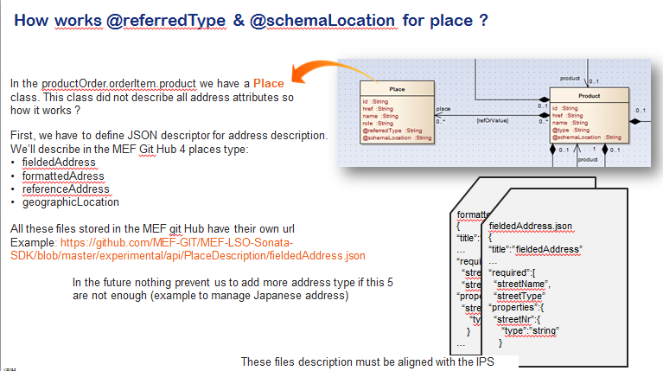

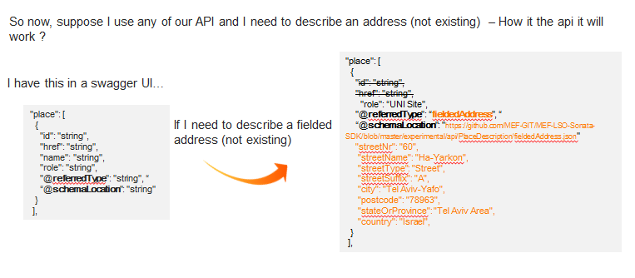

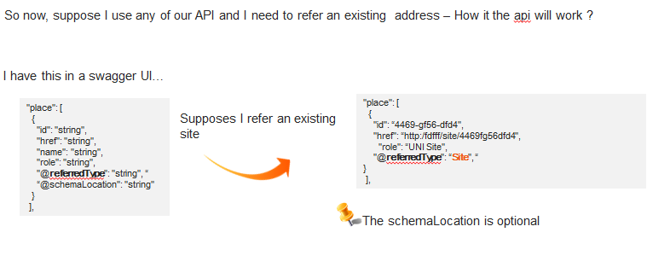

# Appendix – Product Specification Description

## Product Specification management in the API

The productOrder API is product-agnostic. The product specification information is managed with an API extension pattern. This pattern allows distinguishing 2 types of data:

* Catalog information: What are the product specification attributes? What is the attribute format? What is the cardinality of each attribute? In case of a predefined list, what are the values?
* Order-instantiated productSpec description: What are the attributes values for this order? These values should be filled accordingly to catalog information.

The pattern to describe the data is described in the following 3 steps:

Step 1: Identifying the productSpec

Basically, let’s assume an orderItem is describing the order of a productSpecification (and an order is an array of order item) [*That’s a simplification because an order item could also describe a bundledProductOffering with no productSpec… but not currently in the MEF*]

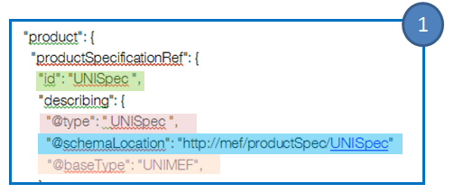The first thing is to identify this productSpecification for the seller by means of an *identifier* (this id is the catalog id of the productSpec for the seller). This id should have been communicated by the seller to the buyer during the on-boarding process between the service provider and the partner (or on-the-fly accessible with a catalog API).

Then we need to provide additional information to retrieve catalog information used to describe this productSpec:

* @type – This is type of productSpec as defined in the MEF. In the example, id and @type have same value but nothing prevents a service provider to have id AZ45hT7 as a productSpec knows a UNISpec in the MEF.
* @schemaLocation describes a URL … and this URL targets the MEF server. Following this URL we have a JSON describing the productSpec. We have there the catalog view of the product spec
* @baseType – is an additional information (optional) to indicate the productSpec category type

@type and @schemaLocation are mandatory information to be filled in the order item.

Step 2: Getting the productSpec description

If we follow the link indicated in the @schemaLocation we reach a JSON file stored in the MEF server where the ordered productSpec catalog description is available. The buyer uses this description to build his order and describe the ordered product.

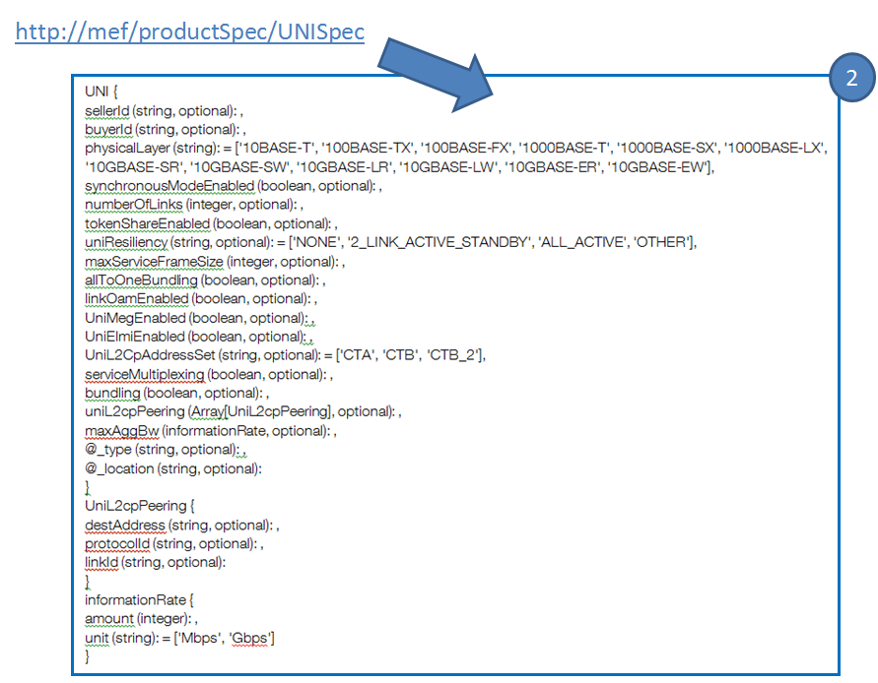We have the following information for the UNI Spec:

We find the description of the UNI productSpec. We can see there that the

* allToOneBundling is an optional boolean,
* physicalLayer is a mandatory attribute and has a pre-defined list,
* maxAggBw is a complex structure which is itself defined there,
* etc…

We note also there that we have @type and @location attributes. These attributes could be optionally used by a service provider to enrich the productSpec with additional attribute specific to this service provider. Use of this extension must be agreed during the on-boarding process between the service provider and the partner.

Step 3: Describing the ordered productSpec

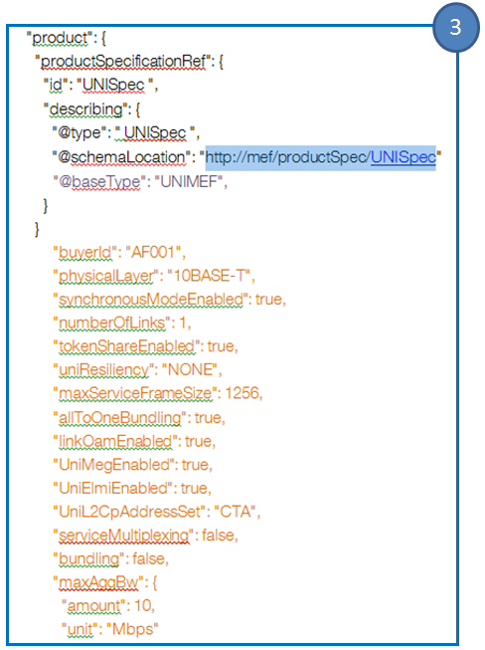The buyer uses the productSpec Description (step 2) to describe the instance of the ordered productSpec. This description is done in a straightforward way with the list of attributes and values directly described in the product structure (in orange).